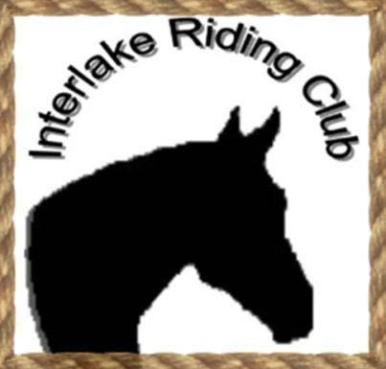
Interlake Riding Club Fun Gymkhana Day
October 11, 2015
Registration 9:30am – 10:30am
NO LATE ENTRIES – Gymkhana starts 11:00am
Rider Name: _________________________________ Age: ___________ Div: ___________
Horse Name: ________________________________ Age: ___________
Breed: _____________________________ Gender: (circle one) M G S
ALL EVENTS $3 PER RIDER – NO HORSE CAN BE USED MORE THAN TWICE PER EVENT.
Pee-Wee: Barrels _____ Poles _____ Keyhole _____
Juicebox Race: Jr Int Sr $
Egg & Spoon: Jr Int Sr $
Relay Flag Race: Jr Int Sr $
Pole Bending: Jr Int Sr $
Barrel Race: Jr Int Sr $
Membership Fee $10 individual or $15 per family: $
Total cost for classes entered: +$
Total cost: $

Interlake Riding Club Fun Gymkhana Day

- Helmets mandatory for riders under age 18, strongly recommended and appreciated to set example by riders over age 18
- All riders MUST be members of Interlake Riding Club
- No other memberships required
- Fees to be paid per rider
- No horse can be used more than twice per event
- Casual dress code but keep it classy
- HAVE FUN!!!

