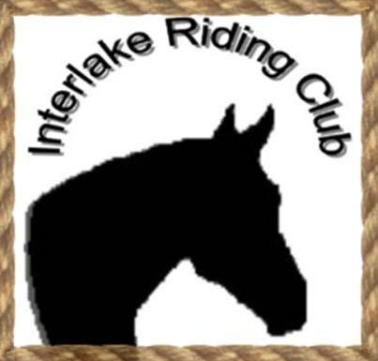
INTERLAKE RIDING CLUB INC.
Membership Application January 2015 – January 2016
Please Print Clearly

Type of Membership: Individual ($10.00) Family ($15.00)
Main Contact: _________________________________________________________
If Family Membership, please print each family member (& age if under 18):

___________________________________________________________________________________________________________________________________________________________________________________________________________________________________________________________________________________________________________________________
Mailing Address (including postal code): Phone Number: _________________________
____________________________________________ Email Address:__________________________
____________________________________________
PREFERRED METHOD OF CONTACT for future meetings and events - CIRCLE ONE PLEASE … Phone Email Regular Mail Facebook
Are you currently a Manitoba Horse Council Member? Yes / No
WAIVER – please read carefully
RESPONSIBILITY CLAUSE – I / We will not hold the Interlake Riding Club, its members and/or Executive, and/or any of the officials/organizers of any meeting, trail ride, clinic, show, or any other event hosted by the IRC, responsible for any personal injury, loss or damage to any person participating or horse exhibited on the premises, nor for any article of any kind that may be lost or destroyed or in any way damaged.

I/ We will be responsible for any injury that may be inflicted to any person or animal or damage to any property while on the grounds of any event, by myself or any horse owned or exhibited by me and shall indemnify the management against all legally established claims or damage of any kind or nature that may grow out of any injury inflicted by any horse owned or exhibited by me.

I / We give the IRC permission to use photographs of me / us in Photo Albums, DVDs, Facebook, and/or Website.

I/ We hereby apply for membership in the INTERLAKE RIDING CLUB and agree to abide by the rules of the Club, as well as agree to the Waiver set out above, as established by the Executive and its Constitution.

SIGNATURE (s): ________________________________________________
(Each member over 18) __________________________________________________________
__________________________________________________________
_________________________________________________

Date: ___________________________

