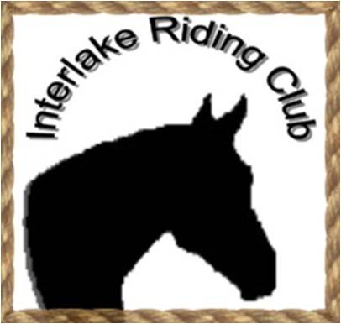
INTERLAKE RIDING CLUB
P.O. Box 930, Teulon, Manitoba R0C 3B0
interlakeridingclub@live.ca

February 2015

To: Businesses, Communities, Organizations, and Fellow Horse & Animal Enthusiasts

Re: Request for Sponsorship of the Interlake Riding Club's Horse Show, Saturday, July 4, 2015

Back in July of 2013, the IRC held its 1st Annual Open Horse show at Green Acres Park, IRC Horse Show/Rodeo Grounds, located in Teulon, MB. This is a NAERIC sanctioned event and part of the North Interlake Show Circuit (N.I.S.C.). The Teulon IRC Show is one of 6 N.I.S.C. shows held throughout the Interlake. Classes will include Halter, Showmanship, Western Pleasure, Reining, Barrel Racing, Trail, English and many more. They consist of four levels of competition -Pee Wee, Junior, Intermediate and Senior. During our first year, our competitor base was at over 70 entries, and last year's 2nd Annual brought 100 entries, not to mention numerous family members and friends who came along with, to support and cheer on the competitors at the very successful events. The event is free to spectators and new to this year is our 4-H High Point Award which will be given to the top 4-H competitor.

This is a major undertaking by the IRC, and to meet the needs of the show and make improvements to the show site, for the benefit of the participants and spectators, we require support from the Agricultural industry and the local community. With this in mind, we are respectfully requesting your support and sponsorship. This may be in the form of items such as equine tack, trophies, ribbons, etc. and/or monetary donations. For your convenience, attached is a list of sponsorship categories. Hopefully we can count on your support in making this a thriving event. We look forward to your reply.

Additional information may be obtained from your local IRC Director or Horse Show Committee Chairperson Heidi Helstrom (204)389-3401 or hph@live.ca.

For monetary donations, cheques can be made payable to the ‘Interlake Riding Club’ and mailed to:
C/o John Logan
Interlake Riding Club
P.O. Box 930
Teulon, MB R0C 3B0

On behalf of the Interlake Riding Club Executive and its membership, we thank you for considering our request. We profoundly thank all our sponsors for their contributions in making this event a great success.

Respectfully,
Heidi Helstrom, IRC Horse Show Committee Chairperson, hph@live.ca or (204)389-3401
John Logan, IRC Treasurer (204-886-2950)
2015 Interlake Riding Club Horse Show
Sponsor Packages Benefits

Platinum Sponsor - $2000* or more (cash or merchandise)
- Banner recognition in the main arena (banner supplied by the sponsor)
- Name listing as a supporter:
- On the FaceBook Page
- On the Entry Form/Program
- Announcer recognition during event

Gold Sponsor - $750 - $1999* (cash or merchandise)
- Name listing as a supporter:
    - On the FaceBook Page
    - On the Entry Form/Program
    - Announcer recognition during event

Silver Sponsor - $250 - $749* (cash or merchandise)
- Name listing as a supporter:
    - On the Entry Form/Program
    - Announcer recognition during event

Bronze Sponsor - $51 - $249* (cash or merchandise)
- Announcer recognition during event

Class Sponsor - $50 (cash)
- Announcer recognition for the class (specific classes may be requested)

*cash or merchandise value

Heidi Helstrom, IRC Horse Show Committee Chairperson, hph@live.ca or (204)389-3401

John Logan, IRC Treasurer (204-886-2950)

