North Interlake Show Circuit Rules and Regulations:
A Grassroots/Novice Horse and Rider Show Circuit
Updated September, 2014
These rules are designed to maintain consistency between the shows for the 9 NISC classes.
AQHA rules are followed with the exception of the following:

Purpose (Goals):
- Promote attendance at all shows within the circuit
- Motivate Competitors
- Promote Good Horsemanship and Sportsmanship
- The NISC yr-end pt summary will recognize the high-point champion and reserve in each age division: Pee Wee, Junior, Intermediate and Senior.

Circuit Shows:
- Stonewall Horse Show – Saturday & Sunday, June 6th & 7th, 2015
- Lundar Horse Show – Friday & Saturday, June 12th & 13th , 2015 www.lundarfair.com
- Teulon Horse Show- Saturday, July4, 2015 www.interlakeridingclub.com
- Arborg Horse Show- Friday & Saturday, July 17th & 18th, 2015 www.agsociety.net
- Eriksdale Horse Show- Sunday, August 8th, 2015
- Ashern Horse Show- Saturday, August 22rd, 2015
- Fraserwood Tumbleweeds Show –Friday & Saturday, September 18th & 19th, 2015

Circuit Membership Fees (NOT for Individual Competitors):
- $300.00 annual fee /per show committee/club. Due Payable at the (Annual Gen Mtg) – the first NISC Meeting held of the year. It is encouraged that someone from each show committee (or a representative that will relay notes) attend the NISC meetings held throughout the year. This will ensure each member club has knowledge of NISC rule updates and changes. It provides consistency, gives each club a voice and the opportunity to be part of the development of the circuit.
- A $100 discount will be applied if a rep is at the annual gen mtg (1st mtg of the yr)

NISC Classes:
- Showmanship
- English Pleasure/Hunter Under Saddle
- English Equitation/Hunt Seat Equitation
- Western Pleasure
- Western Horsemanship
- Rookie Reining –It was suggested that we designate simple reining patterns to help the exhibitors stay on pattern. Going off pattern meant no placing which results in no points. The NISC adopted a Rookie Reining pattern which allows the rider to ride in a 2 hand position in any bit (including a leverage bit) and actually switch from 1 hand to 2 hand positions without going off pattern. It gives Grassroots contestants or Novice horses a better chance of getting around the pattern. The patterns are attached.
- Barrel Racing
- Pole Bending
- Key Hole

Age Divisions:

All ages are as of January 1st of the current year.
- Pee Wee – 8 and under
- Junior – 13 years and under.
- Intermediate – 14 to 18 years
- Senior – 19 years and over

Show Requirements, Class requirements and circuit entry info:
- Shows are not required but only recommended to hold Pee Wee classes for year-end awards.
- Pee Wee classes are offered with the safety of the young competitor in mind. Shows that offer PW classes – may offer any number of classes – but to be NISC recognized are required to offer a min. of 3 of the 9 NISC recognized classes. Pee Wee contestants may compete in their regular Junior classes (listed as 13 & under) but are required to complete the Junior class maneuvers. Pee Wee contestants may not show in a Jr class if a PW class is offered.
- RE: NISC PW division – only points accumulated in the PW classes will be used toward the NISC PW year-end placing.
- Shows are required to host 7 of the 9 classes, with Junior, Intermediate and Senior age divisions although the clubs are strongly urged to host all 9.
- Anyone who competes in a NISC show automatically becomes part of the NISC, there are no individual membership fees. Points are collected on the same horse/rider combinations. Use the same name (registered name) at each show.
- All competitors must compete in their specified age categories to gather pts toward the specified NISC yr-end age div.
- Our circuit encourages participation . We discourage disqualification of competitors except in the case of the safety of competitor or class. Part of our mandate, for NISC shows are to encourage those who want to learn and try.

Show committees: Please inform your judge of the following 7 NISC show requirements:
- AQHA requires any assisted competitors to be disqualified. We want to encourage participation & safety so do allow competitors to be assisted if needed, BUT any contestant being assisted whether hands-on or verbally (both inside or from outside the arena) will be placed under those who are not being assisted in the class in any age division.
- Pee Wees are required to walk and jog only. Loping is not permitted & will be penalized per incident.
- Rookie reining rule allows for the use of 2 hands even with a curb or switching hands positions during your reining class.
- AQHA requires competitors be disqualified for taking the incorrect lead, we would like the judge not to disqualify them but work that fault into their judging score.
- Novice Horses and Novice Rider are encouraged to attend ALL NISC shows. This is including 2 year old horses before July 1st as an exception to the AQHA rule. All horses should be treated with respect at all times.
- If classes are combined then the judge must place all in the class so that the points can be tabulated correctly in each age division for NISC High point awards.
- Each class must be placed to 5th – NISC pts are gathered to 5th place to determine point yr-end hi-pt standings.

Show Results:
- Show committees need to provide a copy of their show results to the NISC tabulator as soon as possible after the show. Show results can be emailed electronically to hph@live.ca. It is very important to count the competitors in the class including disqualifications. Scratches do not count. If classes are combined then the judge must place all in the class so that the points can be tabulated correctly in each age division for NISC High point awards. It is important that competitors enter their horse under its registered name and not its barn name (the same name needs to be used through-out the whole season, otherwise you may find yourself collecting points on 2 different horses.) This is also important for the NAERIC program results as well. This is the responsibility of the exhibitor but should be enforced by the show committee. It may be helpful for the show committee’s to post a note in regards to this at their entry station at each show.
- NISC ties will be broke by: 1- # of shows attended (reward attendance), 2- highest placings (reward performance)

Helmets:
Correctly fitting riding helmets are mandatory for Pee Wee, Junior and Intermediate age divisions for ALL classes. Helmets are recommended for senior riders.

NISC Cross Entry Rule:
- A horse may only be ridden twice per class and only once per age division.

NAERIC Incentive Program:
All of the NISC shows have applied to be NAERIC sanctioned. Each show can apply individually online at www.naeric.org and must publish the results of the show online or in a printed publication placing 1st to 3rd for each class. Contestants can go online to www.naeric.org to enter their placing for each class to redeem their NAERIC rewards.
NISC ROOKIE REINING PATTERN 1

Western Reining Pattern:

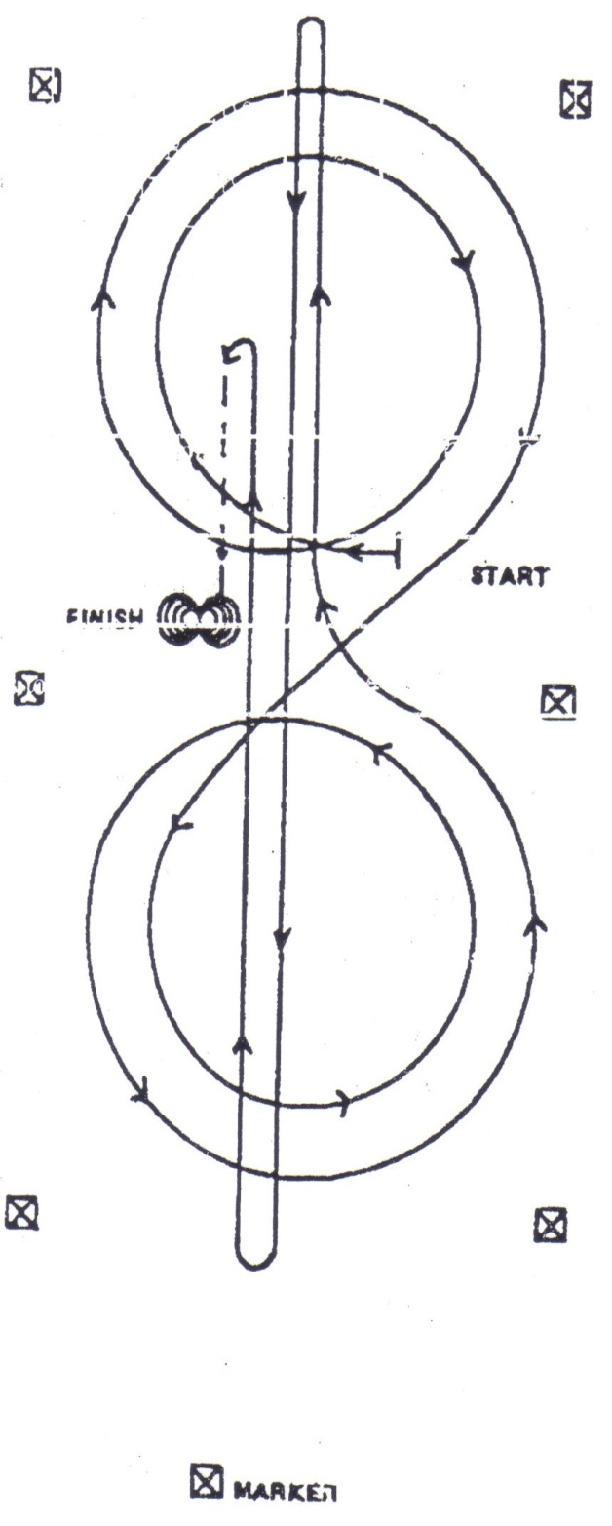
- Begin at center of the arena. Complete two circles to the right. The first small and slow and the second circle large and fast.

- Change leads at the center of the arena.

- Complete two circles to the left. The first circle small and slow, the second circle large and fast.

- Change leads at the center of the arena.

- Run to the far end of the arena – past end marker and do a left rollback – no hesitation.

- Run to the opposite end of arena – past end marker and do a right rollback – no hesitation.

- Run past center of the arena and do a sliding stop.

- Back straight to the center of the arena. Hesitate.

- Complete two spins to the right.
(Juniors are only required to do one spin)

- Complete two spins to the left.
(Juniors are only required to do one spin)

- Hesitate to demonstrate the completion of the pattern.

- Riders may be requested to drop bridle to the judge.

NISC ROOKIE REINING PATTERN 2

Western Reining Pattern:
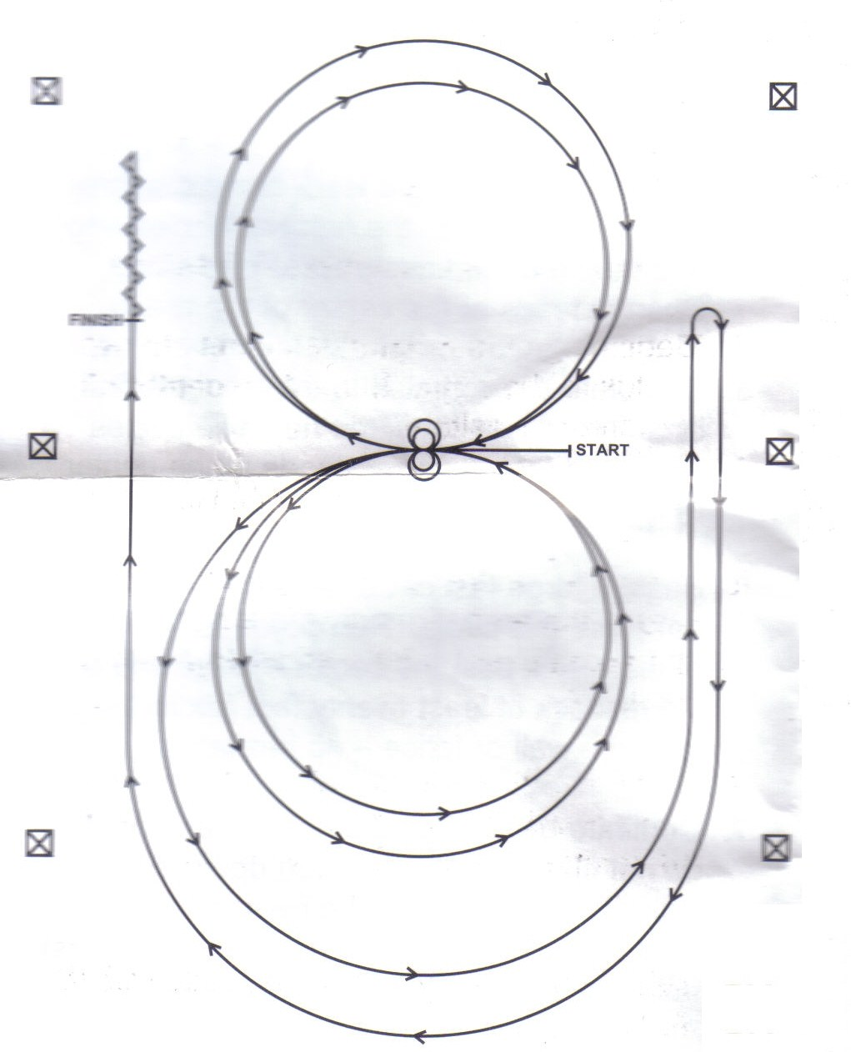
Horses may walk or trot to the center of the arena. Horses must walk or stop prior to starting the pattern. Beginning at the center of the arena facing the left wall or fence.

- Beginning on the left lead, complete two circles to the left. Stop at the center of the arena. Hesitate.

- Complete two spins to the left. Hesitate.

- Beginning on the right lead complete two circles to the right. Stop at the center of the arena. Hesitate.

- Complete two spins to the right. Hesitate.

- Beginning on the left lead, go around the end of the arena, run down the right side of the arena past center marker, stop and roll back right.

- Continue around the end of the arena to run down the left side of the arena past the center marker. Stop. Back up.

